Project Development Phase
Model Performance Test
Date | 10 September 2026
Team ID | SWTID-2026-1448
Project Name | Import Data using Transform Maps (Spreadsheet)
Maximum Marks | 10 Marks

Model Performance Testing:
Project team shall fill the following information in model performance testing template.
S.No. | Parameter | Values | Screenshot
1. | Model Summary | ServiceNow data-import automation using Import Set table Employee Import (u_employee_import), Transform Map Sample Spreadsheet Import and target table Employee Test (u_employee_test) with 5 String fields.  Note: Records are created only when the source data matches the mapped fields; otherwise the Import Log / Transform History shows errors. | 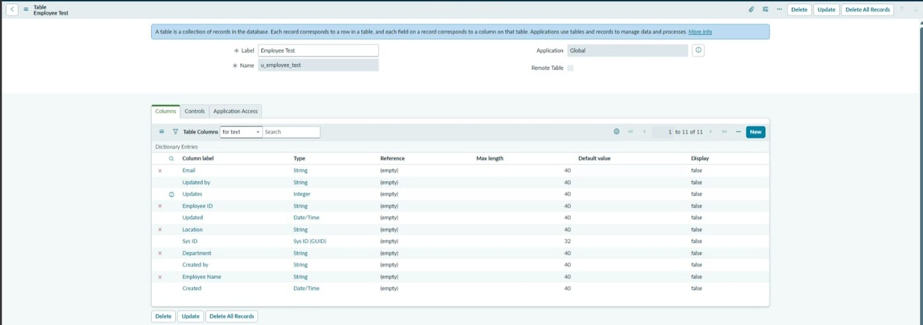  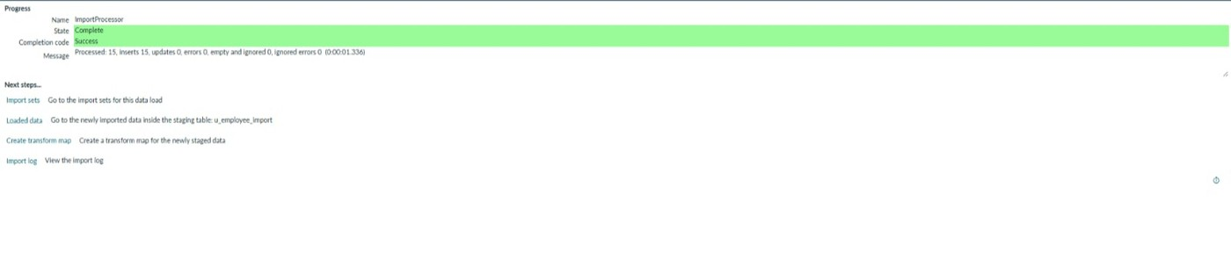
2. | Data Rendered | Source: Sample Spreadsheet.xlsx (Sheet 1, Header row 1) with columns Employee ID, Name, Email, Department, Location.  Initial load: 15 rows processed, 15 inserts, 0 errors. After the second import the table holds 17 records. | 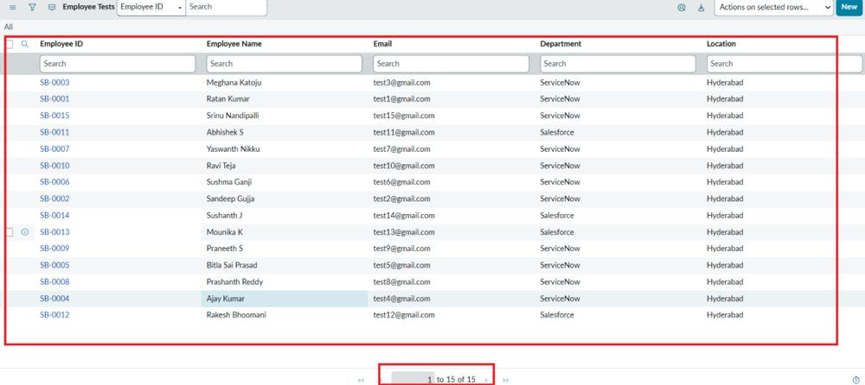
3. | Data Preprocessing (Field Mapping) | Transform Map: Sample Spreadsheet Import (Employee Import → Employee Test), created with Auto Map Matching Fields / Mapping Assist.  Field Maps (5): u_name → u_employee_name, u_employee_id → u_employee_id, u_department → u_department, u_location → u_location, u_email → u_email. | 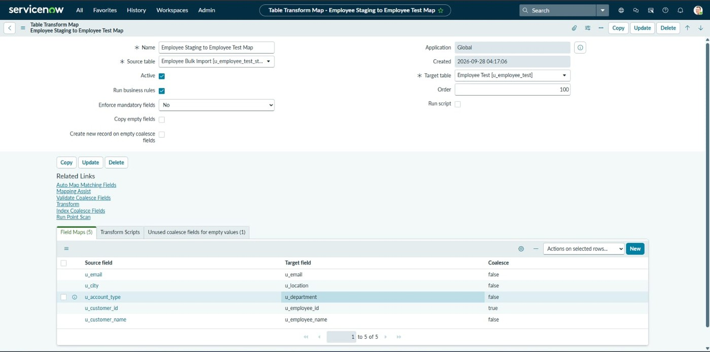
4. | Utilization of Filters (Coalesce) | Coalesce = true on Employee ID (u_employee_id) to match existing records and prevent duplicates.  Rule: matching ID → record updated; new ID → record inserted; identical data → row ignored.
5. | Import Accuracy | Import 1 (15 rows): Inserts 15, Updates 0, Errors 0.  Import 2 (4 rows): Inserts 2, Updates 2, Errors 0.  Import 3 (same 4 rows): Inserts 0, Updates 0, Ignored 4, Errors 0.  Import accuracy: 100% (0 errors in 3 imports). | 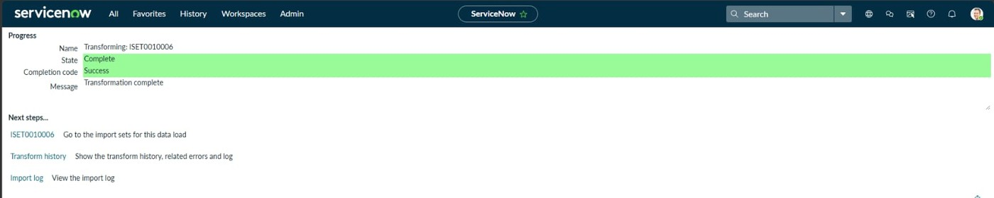  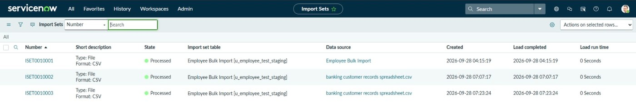  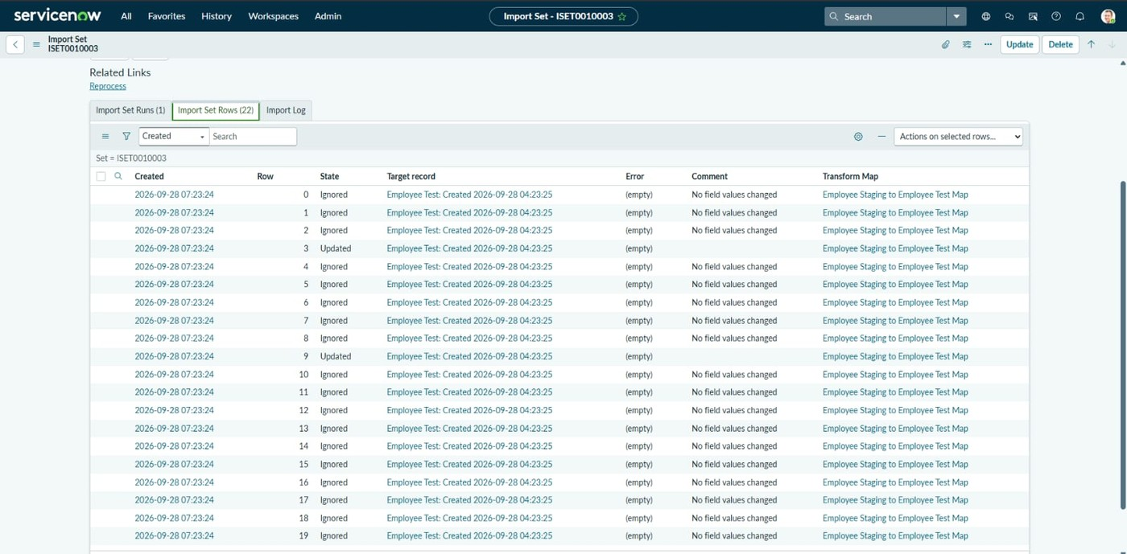
6. | Result Validation | 17 records in Employee Test after imports. SB-0004 name changed to Ajay, SB-0010 email changed to test18@gmail.com, new IDs SB-0016 and SB-0017 added. | 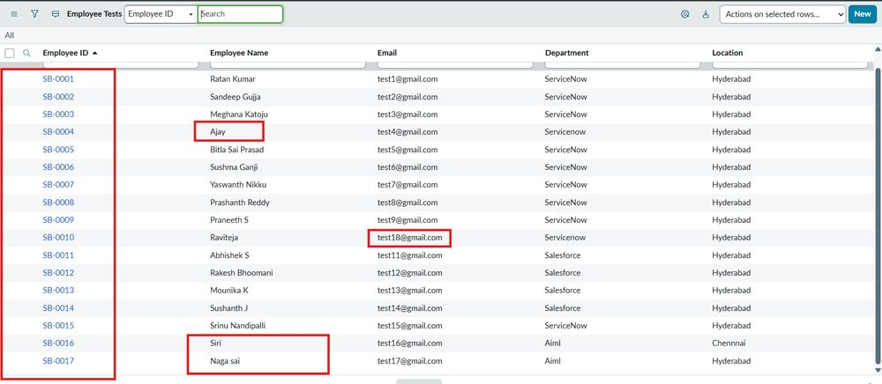
7. | Report Design | No of Visualizations / Graphs - 3  Employees by Department (Pie, Count): ServiceNow 11, Salesforce 4, AIML 2.  Employees by Location (Bar, Count): Hyderabad 16, Chennai 1.  Employee List Report (List): 5 columns, 17 rows. | 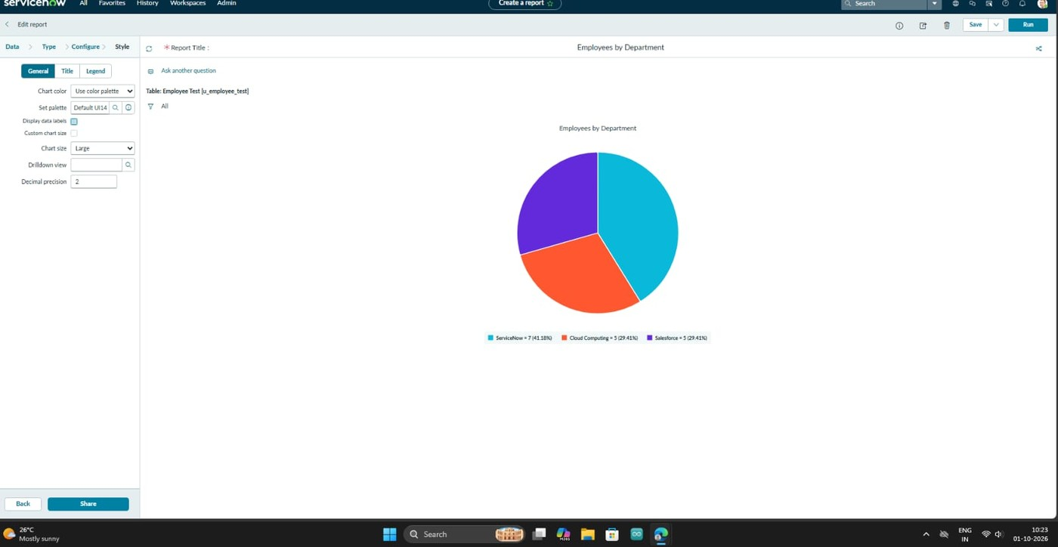  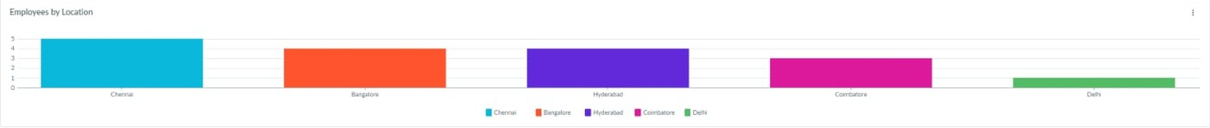  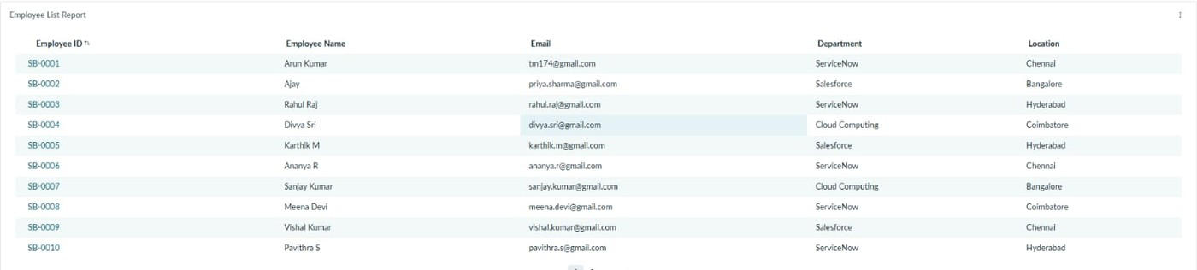
8. | Dashboard Design | No of Visualizations / Graphs - 3  Dashboard: Employee Analytics Dashboard containing all three reports; can be shared with users, groups and roles. | 